**Darcy Sofa**

**Details & Overview $349.99**

**Description**

Talk about fine lines and great curves. That’s the beauty of the Darcy sofa—made to suit your appreciation for clean, contemporary style. A striking flared frame, comfy pillow top armrests and an ultra-soft upholstery that holds up to everyday living complete this fashion statement.

* High-resiliency foam cushions wrapped in thick poly fiber
* Polyester upholstery
* Loose seat and attached back and armrest cushions
* Exposed feet with faux wood finish
* Corner-blocked frame
* Excluded from promotional discounts and coupons

**Fabric Details**

* Body: POLYESTER (100)%

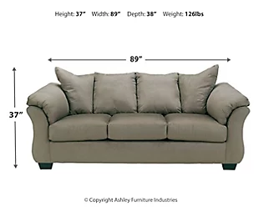**Weight**

126 lbs. (57.15 kgs.)

**Dimensions**

* Width: 89.00"
* Depth: 38.00"
* Height: 37.00"

**Additional Dimensions**

* Seat depth: 22.00"
* Seat height: 21.50"
* Distance between arms: 62.00"c
* Top of cushion to top of back: 18.00"
* Arm height: 31.50"
* Minimum width of doorway for delivery: 32.00"
* Leg height: 3.00"